ASIS Monthly Meeting | - April 2020
Monthly Meeting Schedule  - May 20, 2020- Ralph Pasquariello will be speaking virtually on Cyber Liability  - June 2020 – Pending Speaker Confirmation-If anyone has ideas regarding future speakers, please contact asis.atlanta@gmail.com.  - July 2020- LEAD Event  GSX 2020 Update  The GSX is still on for September 21-23, 2020. However, the ASIS School Grant Program had to be canceled due to the closure of Atlanta Public Schools as a result of COVID-19.  We still need more volunteers for the GSX. We are currently accepting volunteers from outside the Atlanta regional area.  Full Access Passes for volunteers working 16 hours or more-We have a few more left! Sign up now to hold your spot.  1-day Access Passes for volunteers working between 8-15 hours-We have more of these left but sign up to hold your spot.  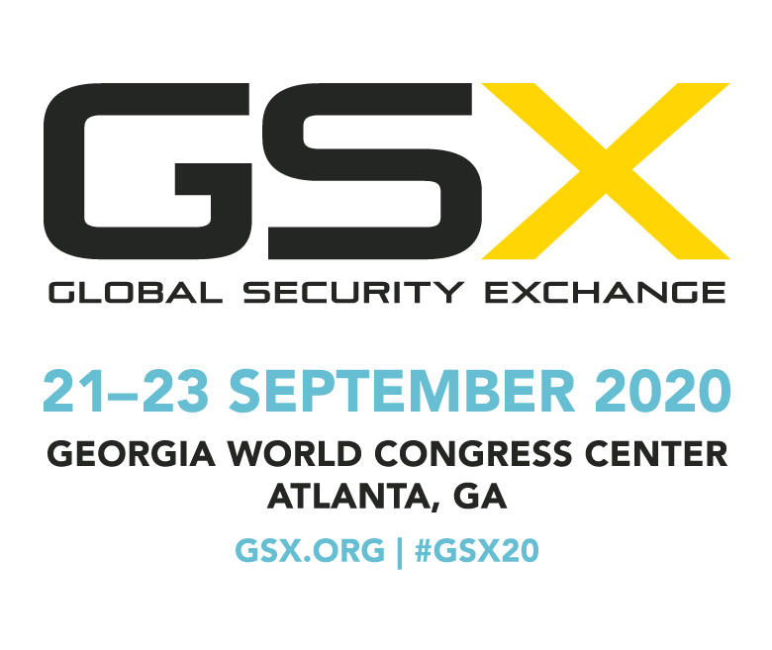 | Treasurer’s Report  As of March 31, 2020, the Chapter account balance was $7,133.86. Because our March meeting was cancelled and we have moved our April meeting to a virtual forum, we have incurred no other expenses since March 1, other than Mailchimp, our email service. Our current account balance includes 2 check deposits from sponsors for the LEAD event. We have kept the remaining received sponsorship monies in the Paypal account until we have confirmation that we are able to move forward with the event in July. This will prevent the Chapter from losing the 3% Paypal fee should we need to refund the sponsors.  LEAD 2020 Update  The LEAD has been rescheduled for Thursday, July 16th. This is subject to change based on guidance from the White House Coronavirus Task Force, and Georgia Governor Brian Kemp.  All pre-LEAD event activities are on hold for now. We will keep you updated as things evolve.

